- Copyright for test papers and marking guides remains with West Australian Test Papers.
- The papers may only be reproduced within the purchasing school according to the advertised conditions of sale.
- Test papers must be withdrawn after use and stored securely in the school until Friday 14th June 2019.

CHEMISTRY

UNIT 3

2019


Name: _________________________________________________________________________________________

Teacher: ________________________________________________________________________________________

TIME ALLOWED FOR THIS PAPER

Reading time before commencing work: ten minutes
Working time for the paper: two hours, thirty minutes

MATERIALS REQUIRED/RECOMMENDED FOR THIS PAPER

To be provided by the supervisor:
This Question/Answer Booklet
Multiple-choice Answer Sheet
Chemistry Data Book

To be provided by the candidate:
Standard items: pens (blue/black preferred), pencils (including coloured), sharpener,
eraser, correction tape/fluid, ruler, highlighters

Special items: up to three non-programmable calculators approved for use in the WACE examinations

IMPORTANT NOTE TO CANDIDATES
No other items may be taken into the examination room. It is your responsibility to ensure that you do not have any unauthorised notes or other items of a non-personal nature in the examination room. If you have any unauthorised material with you, hand it to the supervisor before reading any further.
Structure of this paper

Section | Number of questions available | Number of questions to be answered | Suggested working time  (minutes) | Marks available | Percentage of exam
Section One:  Multiple-choice | 20 | 20 | 40 | /40 | /25
Section Two:  Short answer | 7 | 7 | 50 | /62 | /35
Section Three:  Extended answer | 4 | 4 | 60 | /67 | /40
 |  |  |  |  | /100

Instructions to candidates

1. Answer the questions according to the following instructions.

Section One: Answer all questions on the separate Multiple-choice Answer Sheet provided. For each question shade the box to indicate your answer. Use only a blue or black pen to shade the boxes. If you make a mistake, place a cross through that square then shade your new answer. Do not erase or use correction fluid/tape. Marks will not be deducted for incorrect answers. No marks will be given if more than one answer is completed for any question.

Sections Two and Three: Write your answers in this Question/Answer Booklet.

2. When calculating numerical answers, show your working or reasoning clearly. Express numerical answers to the appropriate number of significant figures and include appropriate units where applicable.

3. You must be careful to confine your responses to the specific questions asked and to follow any instructions that are specific to a particular question.

4. Spare pages are included at the end of this booklet. They can be used for planning your responses and/or as additional space if required to continue an answer.
  - Planning: If you use the spare pages for planning, indicate this clearly at the top of the page.
  - Continuing an answer: If you need to use the space to continue an answer, indicate in the original answer space where the answer is continued, i.e. give the page number. Fill in the number of the question(s) that you are continuing to answer at the top of the page.

5. The Chemistry Data Book is not handed in with your Question/Answer Booklet.

Section One: Multiple-choice 25% (40 marks)

This section has 20 questions. Answer all questions on the separate Multiple-choice Answer Sheet provided. For each question, shade the box to indicate your answer. Use only a blue or black pen to shade the boxes. If you make a mistake, place a cross through that square then shade your new answer. Do not erase or use correction fluid/tape. Marks will not be deducted for incorrect answers. No marks will be given if more than one answer is completed for any question.

Suggested working time: 40 minutes.

Questions 1 and 2 relate to the electrolysis of molten magnesium oxide.

Consider the electrolysis of molten magnesium oxide, MgO(l), using inert graphite electrodes.

1. Which of the following statements is not correct regarding this cell?

- Magnesium is produced at the cathode.
- Oxygen gas is produced at the positive electrode.
- Electrons move from the anode to the cathode.
- Oxide ions are repelled by the anode.

2. For every 1 mole of oxygen gas produced by this cell, the number of moles of magnesium metal produced would be

- 0.5 moles.
- 1.0 moles.
- 1.5 moles.
- 2.0 moles.

3. Which of the following ideas regarding acid-base theory is attributed to the work of BrØnsted and Lowry?

- Bases produce OH⁻(aq) ions in solution.
- Bases are proton donors.
- Acidic solutions contain H₃O⁺(aq) ions.
- Strong acids completely ionise in solution.

4. Which of these substances could be found on the standard reduction potential table?

- 1.5 mol L⁻¹ HCl(aq) at 25 °C.
- 100 kPa H₂(g) at 0 °C.
- 101.3 kPa H₂S(g) at 0 °C.
- 1.0 mol L⁻¹ NaCl(aq) at 25 °C.

Questions 5, 6 and 7 refer to the following information.

Consider the reversible reaction involving the hexaaquairon(III) ion shown below. Assume the reaction is at equilibrium and the K_{c} value is approximately 1 at 25 °C.

[Fe(H₂O)₆]³⁺(aq) + H₂O(l) ⇌ [Fe(H₂O)₅OH]²⁺(aq) + H₃O⁺(aq)
colourless deep orange

If 20 drops of 0.5 mol L⁻¹ HCl(aq) solution was added to this system and a new equilibrium was allowed to establish;

5. Which is the best observation for this?

- Colourless solution becomes deep orange.
- Deep orange solution becomes colourless.
- Orange solution darkens in colour.
- Orange solution fades in colour.

6. At the new equilibrium, which of the following statements is correct?

(a) The rate of the forward reaction is increased.
(b) The rate of the forward reaction is decreased.
(c) The rate of the forward reaction is unchanged.
(d) The rate of the forward reaction is zero.

7. Which species will not have an increase in the number of moles present?

- [Fe(H₂O)₆]³⁺(aq)
- H₂O(l)
- [Fe(H₂O)₅OH]²⁺(aq)
- H₃O⁺(aq)

8. The K_{w} of pure water at 10 °C is 2.92 x 10⁻¹⁵. Which of the following statements must therefore be correct regarding water at 10 °C?

- The [OH⁻] = 5.40 x 10⁻⁸ mol L⁻¹.
- The [OH⁻] < [H₃O⁺].
- The pH of the water is 7.27.
- The water is slightly basic.
- The autoionisation of water is exothermic.

- (i) and (iii) only.
- (i), (ii) and (v) only.
- (iii) and (iv) only.
(d) (ii), (iii) and (iv) only.

Questions 9 and 10 refer to the process of ocean acidification.

Ocean acidification is likely to have many negative consequences for our marine environments. One group of organisms particularly affected are calcifying species.

The four equations below summarise the chemical reactions involved in the process of ocean acidification.

1. H₂CO₃(aq) + H₂O(l) ⇌ H₃O⁺(aq) + HCO₃⁻(aq)
2. HCO₃⁻(aq) + H₂O(l) ⇌ H₃O⁺(aq) + CO₃²⁻(aq)
3. CO₂(g) ⇌ CO₂(aq)
4. CO₂(aq) + H₂O(l) ⇌ H₂CO₃(aq)

9. Place these equations in the correct order to show the series of chemical reactions involved in ocean acidification.

- 3, 2, 1, 4
- 3, 1, 4, 2
- 3, 4, 1, 2
- 4, 3, 2, 1

10. Which of the following does not contribute to the problems faced by calcifying species as a direct result of ocean acidification?

(a) A decrease in ocean CO₃²⁻(aq) concentration.
(b) A decrease in ocean Ca²⁺(aq) concentration.
(c) An increase in ocean H₃O⁺(aq) concentration.
(d) A decrease in the presence of CaCO₃(s).

11. Which of these lists contains species showing oxygen in three different oxidation states?

- O₂ H₂O₂ MgO
- F₂O H₂O SO₄²⁻
- H₂O₂ SO₄²⁻ MgO
- H₂O O₂ SO₄²⁻

12. Which of the following are homogeneous equilibrium systems?

- HCOOH(l) + CH₃CH₂OH(l) ⇌ HCOOCH₂CH₃(l) + H₂O(l)
- SbCl₅(g) ⇌ SbCl₃(g) + Cl₂(g)
- Ca(OH)₂(s) ⇌ Ca²⁺(aq) + 2 OH⁻(aq)

- (ii) only
- (iii) only
- (ii) and (iii) only
- (i) and (iii) only

13. The rate of decomposition of solid calcium carbonate was being investigated.

CaCO₃(s) + heat ⇌ CaO(s) + CO₂(g)

A graph was drawn to show how the moles of CO₂(g) changes over time, as the reaction establishes equilibrium in a closed system. This is represented by the solid line on the graph below.

Time
Moles of CO₂(g)
A
B
original conditions

Consider the effect of individually altering (i.e. only changing one at a time) the following conditions and carrying out the reaction again.

- Increasing the mass of CaCO₃(s).
- Increasing the subdivision of CaCO₃(s).
- Increasing the temperature of the system.
- Adding an appropriate reaction catalyst.

Which of these alterations could result in the curve labelled A?

- (i) only
- (ii) only
- (iii) only
- (iv) only

14. Use the standard reduction potential table to determine the correct ionic equation for the reaction between acidified aqueous sodium dichromate and hydrogen peroxide solution.

(a) H₂O₂(aq) + 6 H⁺(aq) + Cr₂O₇²⁻(aq) → O₂(g) + 2 Cr³⁺(aq) + 3 H₂O(l)
(b) Cr₂O₇²⁻(aq) + 8 H⁺(aq) + 3 H₂O₂(aq) → 2 Cr³⁺(aq) + 7 H₂O(l) + 3 O₂(g)
(c) 3 H₂O₂(aq) + Cr₂O₇²⁻(aq) + 6 H⁺(aq) → 7 H₂O(l) + 3 O₂(g) + Cr³⁺(aq)
(d) Cr₂O₇²⁻(aq) + H₂O₂(aq) + 2 H⁺(aq) → O₂(g) + 2 Cr³⁺(aq) + 3 H₂O(l)

Questions 15 and 16 refer to the following equilibrium system.

Consider the following reversible gaseous system. Assume the reaction is at equilibrium.

CO₂(g) + 4 H₂(g) ⇌ CH₄(g) + 2 H₂O(g) + heat

15. Increasing the temperature of the system would

- increase the yield of CH₄(g).
- increase the average kinetic energy of the particles.
- increase the activation energy.
- increase the heat of reaction.

16. A chemist devised a way to remove methane from the system as it forms. This would

- increase the rate of the forward reaction.
- decrease the yield.
- increase the rate of the reverse reaction.
- create an open system.

17. Consider the following pieces of glassware, both of which are used for measuring liquid volumes.

50 mL measuring cylinder 25 mL pipette

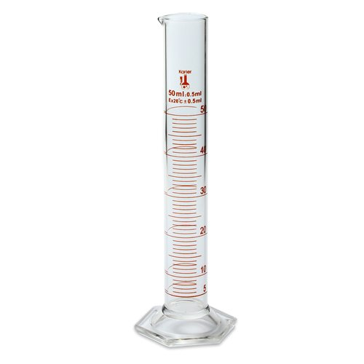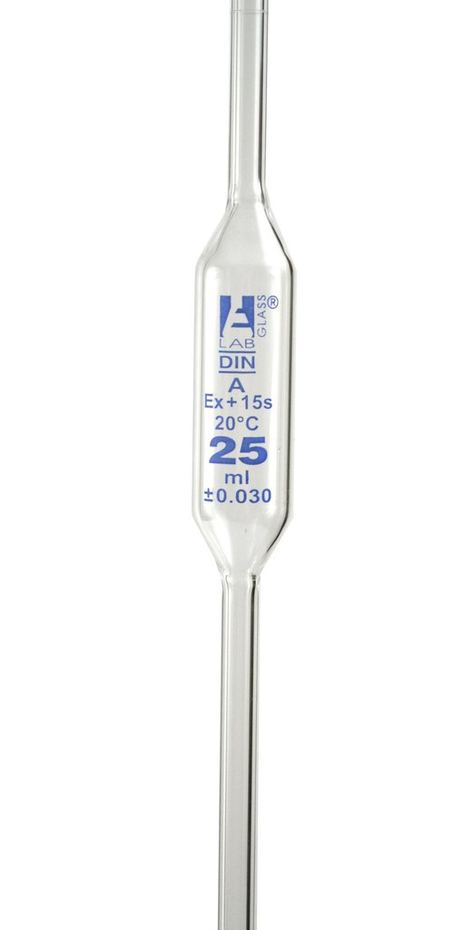
50 mL ± 0.5mL
Ex 20°C ± 0.5mL

25 mL ± 0.03 mL
Ex 20°C ± 0.03 mL

If each of these pieces of equipment was used to measure a 50 mL aliquot of water at 20 °C, the most accurate recordings possible are

50 mL measuring cylinder 25 mL pipette
- 50 ± 0.5 mL 50 ± 0.03 mL
- 50 ± 0.5 mL 50 ± 0.06 mL
- 50 ± 1.0 mL 50 ± 0.03 mL
- 50 ± 1.0 mL 50 ± 0.06 mL

Questions 18 and 19 relate to the data below.

Four (4) different beakers were set up, each containing a different salt solution. A piece of cobalt metal was then placed in each. The beakers contained the combinations shown in the table.

A | B | C | D
Co(s) + Cd²⁺(aq) | Co(s) + Zn²⁺(aq) | Co(s) + Sn²⁺(aq) | Co(s) + Fe²⁺(aq)

18. In which of the beaker(s) would the metal donate electrons?

- C
- A and B
- B and C
- A, B and D

19. The strongest reducing agent is

- Sn²⁺(aq)
- Co(s)
- Fe²⁺(aq)
- Zn²⁺(aq)

20. Consider the rate graph below, showing a system establishing equilibrium.

0 E1
Time
Rate
forward reaction
reverse reaction
Which statements are correct regarding this graph?

- At Time 0, the forward reaction rate is zero.
- At Time E1, the forward reaction rate is zero.
- From Time 0 to E1, the forward reaction rate is increasing.
- From Time 0 to E1, the reverse reaction rate is greater than the forward reaction rate.
- At Time E1, the reverse reaction rate reaches a maximum.

- (i), (ii) and (iv) only
- (i), (iii) and (iv) only
- (ii), (iv) and (v) only
- (iii), (iv) and (v) only

End of Section One

Multiple-choice Answer Sheet

Name: ANSWERS

INSTRUCTIONS

For each question shade the box to indicate your answer.
Use only a blue or black pen to shade the boxes.

For example, if b is your answer: a □ b ■ c □ d □

If you make a mistake, place a cross through that square and shade your new answer. Do not erase or use correction fluid/tape.

For example, if b is a mistake and d is your answer: a □ b ■ c □ d ■

If you then want to use your first answer b, cross out d and then circle b.
a □ b ■ c □ d ■
Marks will not be deducted for incorrect answers.
No marks will be given if more than one answer is completed for any question.

1 | a □ b □ c □ d □ |  | 11 | a □ b □ c □ d □
2 | a □ b □ c □ d □ |  | 12 | a □ b □ c □ d □
3 | a □ b □ c □ d □ |  | 13 | a □ b □ c □ d □
4 | a □ b □ c □ d □ |  | 14 | a □ b □ c □ d □
5 | a □ b □ c □ d □ |  | 15 | a □ b □ c □ d □

6 | a □ b □ c □ d □ |  | 16 | a □ b □ c □ d □
7 | a □ b □ c □ d □ |  | 17 | a □ b □ c □ d □
8 | a □ b □ c □ d □ |  | 18 | a □ b □ c □ d □
9 | a □ b □ c □ d □ |  | 19 | a □ b □ c □ d □
10 | a □ b □ c □ d □ |  | 20 | a □ b □ c □ d □

Section Two: Short answer 35% (62 marks)

This section has 7 questions. Answer all questions. Write your answers in the spaces provided.

When calculating numerical answers, show your working or reasoning clearly. Express numerical answers to the appropriate number of significant figures and include appropriate units where applicable.

Spare pages are included at the end of this booklet. They can be used for planning your responses and/or as additional space if required to continue an answer.
- Planning: If you use the spare pages for planning, indicate this clearly at the top of the page.
- Continuing an answer: If you need to use the space to continue an answer, indicate in the original answer space where the answer is continued, i.e. give the page number. Fill in the number of the question(s) that you are continuing to answer at the top of the page.

Suggested working time: 50 minutes. STATES NOT REQUIRED UNLESS OTHERWISE STATED

Question 21 (7 marks)

A group of chemistry students constructed the electrochemical cell shown below.

V
Zn(NO₃)₂(aq)
Zn(s)
Ni(s)
Ni(NO₃)₂(aq)
A
B

(a) Note any changes the students would have observed in each half-cell. (3 marks)

A | No changes observed (1)
B | Green solution fades in colour, electrode decreases in size, new silver/grey solid forms (2; any two changes)

(b) Explain why no voltage was produced in this electrochemical cell and state what the students could do to correct the set up. (2 marks)

- a metal displacement reaction occurs in half-cell B therefore there is no potential difference between cells / no current flows through the external circuit

OR - the oxidant is in contact with the reductant (1)

- swapping the electrodes (or the electrolyte beakers) will correct the set up (1)

The students corrected their set up of the cell and it was functioning as expected.

(c) Write the overall equation for the reaction occurring in this cell. (1 mark)

Zn(s) + Ni²⁺(aq) → Ni(s) + Zn²⁺(aq)
OR Zn(s) + Ni(NO₃)₂(aq) → Ni(s) + Zn(NO₃)₂(aq)

(d) What is the maximum EMF that could be recorded for this cell if it was operating under standard conditions? (1 mark)

EMF = - 0.24 + 0.76 = 0.52 V

(UNITS REQUIRED, WORKING NOT REQUIRED)

Question 22 (10 marks)

Read the following passage regarding the pH of soils.

Soil pH is a very important factor that contributes to the healthy growth of a plant. A soil pH that is too acidic or too alkaline can affect the ability of a plant to take up nutrients such as nitrogen, phosphorus and sulfur. There are many fertilisers and other chemicals that can be added to soils to alter the pH to the desired level.

Potash, which contains potassium chloride (KCl), increases the water uptake of a plant and improves the yield of a crop.

Many fertilisers contain nitrogen and phosphorus in the form of compounds such as ammonium nitrate (NH₄NO₃) or calcium dihydrogenphosphate (Ca(H₂PO₄)₂). These are used to improve the growth and health of plants.

Many farmers also add agricultural lime to their soil, which consists of pulverised limestone (CaCO₃), to decrease water runoff.

a) Select a compound from the passage above that you could add to soil to; (4 marks)

- increase the pH. Support your answer with an appropriate chemical equation.

- CaCO₃ (1)

- CO₃²⁻(aq) + H₂O(l) ⇌ HCO₃⁻(aq) + OH⁻(aq) (1)

- decrease the pH. Support your answer with an appropriate chemical equation.

- NH₄NO₃ (1)
- NH₄⁺(aq) + H₂O(l) ⇌ NH₃(aq) + H₃O⁺(aq) (1)
OR
- Ca(H₂PO₄)₂ (1)
- H₂PO₄⁻(aq) + H₂O(l) ⇌ HPO₄²⁻(aq) + H₃O⁺(aq) (1)

To test the pH of the soil, 1 g of soil can be mixed in a test tube with either 5 mL of distilled water or 5 mL of 0.01 mol L⁻¹ CaCl₂(aq). The test tube is then shaken, and a few drops of universal indicator is added to measure the pH.

(b) Explain why mixing the soil with CaCl₂(aq) will give the same measured pH as mixing the soil with water. (2 marks)

- it is a neutral salt (1)
- neither the Ca²⁺ or the Cl⁻ ion hydrolyses with water (1)

Red cabbage leaves can be used to produce an indicator. Once the leaves are boiled in water, the liquid can then be collected and used to distinguish between acidic and alkaline solutions.

The general equation illustrating the ability of red cabbage indicator (denoted as HInd / Ind ⁻) to change colour is shown below.

HInd(aq) + H₂O(l) ⇌ Ind ⁻ (aq) + H₃O⁺(aq)
red green

A few drops of red cabbage indicator was added to separate samples of 0.1 mol L⁻¹ HCl(aq) and 0.1 mol L⁻¹ NaOH(aq).

(c) Use Le Chatelier’s principle and the equation above, to justify how the addition of several drops of indicator results in a visible colour change in each case. (4 marks)

- in acid solution, [H₃O⁺] is high which favours the reverse reaction/ causes equilibrium to shift left (1)

- this causes the indicator to appear red (1)

- in basic solution, [H₃O⁺] is low (neutralised by the OH⁻) which favours the forward reaction/ causes equilibrium to shift right (1)

- this causes the indicator to appear green (1)

Question 23 (9 marks)

Potassium hydrogen iodate, KH(IO₃)₂, is a common primary standard used in acid-base titrations.

A sample of KH(IO₃)₂(s) weighing 1.218 g was dissolved in distilled water and made up to 250.0 mL in a volumetric flask. 20.00 mL aliquots of this primary standard were taken and titrated against a sodium hydroxide solution, NaOH(aq), of unknown concentration. An average titre of 23.74 mL was required to reach the end point.

The equation for the titration reaction is;

KH(IO₃)₂(aq) + NaOH(aq) → NaIO₃(aq) + KIO₃(aq) + H₂O(l)

(a) List two (2) characteristics that KH(IO₃)₂ must have in order to be used as a primary standard. (2 marks)

- high molar mass
- not deliquescent / hygroscopic
- soluble in water
- obtainable in pure form (any 2 relevant characteristics)

(b) Calculate the concentration of the NaOH(aq) solution. State your answer to the appropriate number of significant figures. (7 marks)

M(KH(IO₃)₂) = 39.1 + 1.008 + 2 x 126.9 + 6 x 16 = 389.908 gmol⁻¹ (1)

n(KH(IO₃)₂)_{total} = m/M = 1.218 / 389.908 = 0.0031238 mol (1)

EITHER: c(KH(IO₃)₂) = n/V = 0.0031238 / 0.250 = 0.012495 mol L⁻¹ (1)

and n(KH(IO₃)₂)_{aliquot} = cV = 0.012495 x 0.020 = 2.49905 x 10⁻⁴ mol (1)

OR: n(KH(IO₃)₂)_{aliquot} = (V_{aliquot}/V_{total}) x n_{total} (1)
= (0.02/0.25) x 0.0031238
= 2.49905 x 10⁻⁴ mol (1)

n(NaOH)_{titre} = n(KH(IO₃)₂)_{aliquot} = 2.49905 x 10⁻⁴ mol (1)

c(NaOH) = n/V = 0.000249905 / 0.02374 = 0.01052675 = 0.01053 mol L⁻¹ (1)

(1 for 4 SF)

Question 24 (9 marks)

The following equation shows the equilibrium that exists between tetraphosphorus (P₄) and diphosphorus (P₂) in a reaction chamber at 1000 °C.

P₄(g) + heat ⇌ 2 P₂(g)

A sample of P₄(g) was injected into an evacuated chamber, where the temperature was maintained at 1000 °C. The initial partial pressure of P₄(g) was 183 kPa. The system was allowed to establish equilibrium and this occurred at Time E1. At this time, the partial pressure of P₄(g) was 158 kPa.

(a) Sketch a graph on the axes below, showing the partial pressure changes of both species from Time 0 until the establishment of equilibrium at Time E1. Continue your sketch after Time E1 to illustrate the attainment of equilibrium. (4 marks)

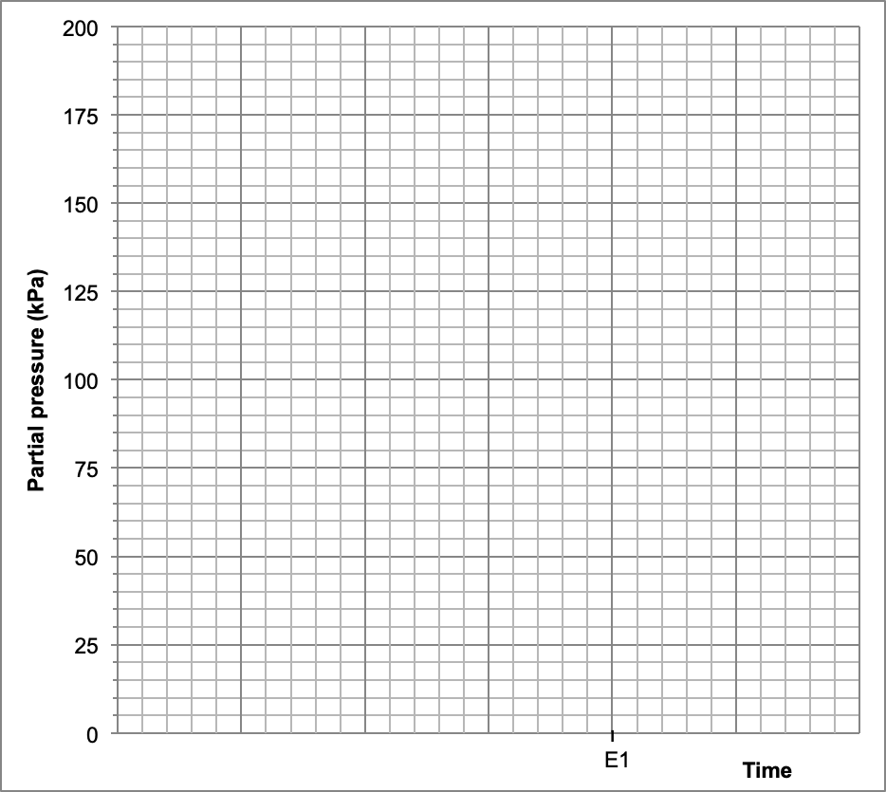
P₂
P₄

(1 for P₄ start/end value, 1 for P₂ start/end value,
1 for shape of curves from Time 0 to E1, 1 for horizontal after E1)
(b) Write the equilibrium constant (K) expression for this reaction. (1 mark)

K = [P₂]²
[P₄]

(c) Predict how
- the mass of P₂(g), and
- the forward reaction rate
will differ from their original equilibrium values at E1 after the following changes are imposed on the system and equilibrium has been re-established. Use the terms increase, decrease or no change. (4 marks)

 | Mass of P₂(g) present  (increase, decrease, no change) | Rate of forward reaction  (increase, decrease, no change)
Temperature decreased | decrease | decrease
Total volume increased | increase | decrease

(1 mark per box)

Question 25 (10 marks)

The final stage of copper refining involves the electrochemical process illustrated below.

blister copper
+ –
CuSO₄(aq) / H⁺(aq)
pure copper

(a) Write the overall equation for this electrochemical cell. (1 mark)

Cu²⁺(aq) + Cu(s) → Cu(s) + Cu²⁺(aq) (or no reaction)

(b) Is this a galvanic or electrolytic cell? Justify your answer. (2 marks)

- electrolytic (1)
- electrical energy is applied to cause a chemical reaction that would not otherwise occur/ reaction has an Eº of zero (1)

(c) Describe briefly the sequence of steps that an atom of copper takes as it moves from the blister copper electrode to the pure copper electrode. (5 marks)

- copper atom at anode loses 2 electrons / copper atom is oxidised / copper atom becomes a copper ion / Cu → Cu²⁺ + 2e⁻ (2 of these points for 2 marks)

- copper ion moves into electrolyte and travels to cathode (1)

- copper ion picks up 2 electrons at cathode / Cu²⁺ + 2e⁻ → Cu / copper ion becomes copper metal / copper ion is reduced and plates (2 of these points for 2 marks)

The CuSO₄(aq) electrolyte is acidified with H₂SO₄(aq) to prevent oxygen gas forming at the blister copper electrode.

(d) Explain how the formation of O₂(g) would be possible in the absence of acid. Support your answer with a relevant half-equation. (2 marks)

- the oxygen could be formed by the oxidation of water (1)

- 2 H₂O(l) → O₂(g) + 4 H⁺(aq) + 4 e⁻ (1)
Question 26 (9 marks)

A group of chemistry students was investigating buffers. They prepared four (4) different solutions in separate beakers, as shown below.

HNO₂(aq) / H₂O(l)
HCl(aq) / NaCl(aq)
NaCl(aq) / H₂O(l)
HNO₂(aq) / KNO₂(aq)

They then tested the ability of each solution to act as a buffer, by adding NaOH(aq) dropwise to each beaker and recording the pH.

The results of their investigation are shown in the table below.

 |  | Drops of NaOH(aq) added
Solution |  | 0 | 5 | 10 | 15 | 20 | 25 | 30
pH | A | 1.6 | 3.3 | 4.5 | 9.4 | 10.6 | 12.2 | 12.9
 | B | 5.9 | 5.9 | 5.9 | 6.0 | 6.0 | 6.1 | 6.1
 | C | 3.7 | 5.1 | 8.8 | 10.1 | 11.5 | 11.9 | 12.1
 | D | 7.0 | 10.2 | 11.8 | 12.5 | 12.8 | 12.9 | 13.0

(a) Match each solution with its identity. (4 marks)

A | HCl / NaCl
B | HNO₂ / KNO₂
C | HNO₂ / H₂O
D | NaCl / H₂O
(1 per box)
(b) Justify your choices in part (a). (5 marks)

- A has must be HCl/NaCl as it has the lowest pH (1)

- Only B demonstrates ability to buffer (since pH does not alter greatly) (1)

- It must be HNO₂/KNO₂, as this is the only solution that contains a weak acid and its conjugate base (1)

- C must contain the HNO₂/H₂O as it has moderately low pH, and does not have the ability to buffer (1)

- D must contain NaCl/H₂O, as it has a neutral pH (1)
Question 27 (8 marks)

The formic acid fuel cell is commonly used in small portable devices, as well as having some application in vehicles. The cell uses formic acid (HCOOH) as the fuel, in addition to oxygen gas which is extracted from the air. It is able to produce an EMF of 1.45 V under standard conditions. As the cell operates (under acidic conditions), carbon dioxide gas and water vapour are produced.

(a) Complete the table below by writing the cathode and anode half-equations, the overall cell equation and calculating the voltage data (assuming standard conditions). (5 marks)

Cathode half-equation | O₂(g) + 4 H⁺(aq) + 4 e⁻ → 2 H₂O(l) | E⁰_{(red)} = +1.23 V
Anode half-equation | HCOOH(aq) → CO₂(g) + 2 H⁺(aq) + 2 e⁻ | E⁰_{(ox)} = +0.22 V
Overall equation | 2 HCOOH(aq) + O₂(g) → 2 H₂O(l) + CO₂(g) | EMF = 1.45 V
(1 per box)

(b) State an environmental disadvantage of using formic acid as a fuel instead of hydrogen gas, H₂(g). (1 mark)

CO₂ is produced which is a greenhouse gas (whereas hydrogen fuel cell only produces water) (1)

The EMF produced by the formic acid fuel cell is greater than that produced by the hydrogen-oxygen acid fuel cell.

(c) What information does this provide regarding the comparative strength of H₂ and HCOOH as reductants (reducing agents)? Justify your answer. (2 marks)

- HCOOH is a stronger reductant (1)

- the half-cells must be further apart on the SRPT / there is a greater difference in E⁰ value when HCOOH is used / oxidation of HCOOH has a more positive Eº value (1)

End of Section Two

Section Three: Extended answer 40% (67 marks)

This section contains four (4) questions. You must answer all questions. Write your answers in the spaces provided below.

Where questions require an explanation and/or description, marks are awarded for the relevant chemical content and also for coherence and clarity of expression. Lists or dot points are unlikely to gain full marks.

Final answers to calculations should be expressed to the appropriate number of significant figures.

Spare pages are included at the end of this booklet. They can be used for planning your responses and/or as additional space if required to continue an answer.
- Planning: If you use the spare pages for planning, indicate this clearly at the top of the page.
- Continuing an answer: If you need to use the space to continue an answer, indicate in the original answer space where the answer is continued, i.e. give the page number. Fill in the number of the question(s) that you are continuing to answer at the top of the page.

Suggested working time: 60 minutes.

Question 28 (16 marks)

Ozone is an important chemical within our atmosphere and acts as a protective shield to stop many of the harmful ultraviolet rays from the Sun reaching us. One of the many important reactions occurring in our atmosphere is that between molecules of ozone (O₃) and nitric oxide (NO).

Nitric oxide is produced from natural occurrences such as lightning, forest fires and chemical processes in the soil, as well as in large amounts from human activities involving the use of fossil fuels.

Nitric oxide is an unstable molecule, and when it comes into contact with ozone the following reaction takes place, producing nitrogen dioxide (NO₂) and oxygen (O₂).

O₃(g) + NO(g) ⇌ NO₂(g) + O₂(g)

The reaction between ozone and nitric oxide is referred to as ‘chemiluminescent’ because it produces light. Whilst nitrogen dioxide is a brown gas, the other gases involved in this reaction are colourless.

Due to the importance of this reaction within our atmosphere, much study has been done regarding the thermodynamics of this process, as well as the effects of temperature and pressure on this system.

The activation energy for the forward reaction is 10.8 kJ, whilst the activation energy for the reverse reaction is 210.5 kJ.

Using the information given;

(a) Sketch an energy profile diagram for this reaction. Label the enthalpy change along with its value. (3 marks)

Progress of reaction
Potential energy (kJ)

O₃ + NO
ΔH = -199.7 kJ
NO₂ + O₂

(1 for shape, 1 for reactants/products labels, 1 for ΔH value and label)

Considering the activation energy values provided;

(b) Comment on the likely reversibility of this reaction and explain how this would affect the size of the equilibrium constant (K_{c}). (3 marks)

- not likely to be very reversible, as Ea(rev) is much larger than Ea(fwd) (1)

- so products will outnumber reactants at equilibrium(1)

- resulting in a large value of K_{c} (1) (or K_{fwd} >>>> K_{rev})

The reaction between ozone and nitric oxide was studied in a closed system, by injecting both gases into an evacuated chamber. Equilibrium was then allowed to establish.

Various changes were made to the system and the resultant effects were examined. Some of the data collected is displayed in the following graph. Note that only the nitrogen-containing species have been plotted.

O₃(g) + NO(g) ⇌ NO₂(g) + O₂(g)

l l l
T1 T2 T3

Time
Partial pressure (kPa)

l l l l l l l l l
NO₂(g)
NO(g)

(c) State the change imposed at T1. Give any corresponding observations. (3 marks)

- doubling of total pressure / halving of total volume (2)

(allocate 1 mark for ‘pressure increase / volume decrease’ without note of ‘doubling/halving’)

- brown colour of gas mixture darkens (1)

(d) Explain the shape of the graph between T1 and T2. (2 marks)

- equilibrium is not disturbed/ system at equilibrium (1)

- since there are equal number of moles of gas on both sides of the equation (1)

At T2 the temperature of the system was increased, followed by the re-establishment of equilibrium at T3.

(e) Sketch a graph showing the effect on both the forward and reverse reaction rates between T2 and T3. Label the forward and reverse reaction rates. (2 marks)

reverse
forward
l l
T2 T3
Time
Reaction rate

(1 for initial large increase in reverse and small increase forward,
1 for reverse and forward then coming together and horizontal at T3)
((-1) if no for/rev labels shown, use of solid/dotted line is acceptable for labelling)

(f) State one other change that could have been made to the system which would have resulted in the partial pressure changes observed (see original graph on previous page) between T2 and T3. Justify your answer. (3 marks)

- increase partial pressure of O₂ / increase concentration of O₂ / inject some O₂
- this would favour the reverse reaction in order to decrease the concentration of O₂ (or correct CT explanation)
- this would result in the observed decrease in NO₂ and increase in NO

OR

- decrease partial pressure of O₃ / decrease concentration of O₃ / remove some O₃
- this would favour the reverse reaction in order to increase the concentration of O₃ (or correct CT explanation)
- this would result in the observed decrease in NO₂ and increase in NO

Question 29 (18 marks)

‘Aqua regia’ is a mixture of nitric acid and hydrochloric acid and is typically made by combining HNO₃(aq) and HCl(aq) in the optimal molar ratio of 1:3 respectively.

As soon as nitric and hydrochloric acids are mixed, the aqua regia solution produced has a yellow-orange fuming appearance. It is very reactive and quickly begins to decompose, therefore the solution needs to be prepared just before use.

A fresh batch of aqua regia was being prepared by a chemist. If the beaker already contained 165 mL of 0.152 mol L⁻¹ HNO₃(aq);

(a) Calculate the volume of 0.218 mol L⁻¹ HCl(aq) that should be added to this to produce the optimum composition aqua regia. (3 marks)

n(HNO₃) = cV = 0.152 x 0.165 = 0.02508 mol (1)

n(HCl) = 3 x n(HNO₃) = 0.07524 mol (1)

V(HCl) = n/c = 0.07524 / 0.218 = 0.3451 = 0.345 L or 345 mL (3SF) (1)

(b) Calculate the pH of the aqua regia solution upon initial mixing of the two acids. (3 marks)

n(H⁺) = n(HCl) + n(HNO₃) = 0.07524 + 0.02508 = 0.10032 mol (1)

c(H⁺) = n/V = 0.10032 / 0.510 = 0.1967 mol L⁻¹ (1)

pH = -log[H⁺] = -log 0.1967 = 0.706196 = 0.706 (3SF) (1)

After the chemist had finished his laboratory work, 125 mL of the aqua regia remained. Due to its extremely reactive nature, aqua regia needs to be neutralised before disposal. If 42.0 mL of 0.545 mol L⁻¹ potassium hydroxide (KOH) solution was added to this beaker of aqua regia;

(c) Would this be sufficient to neutralise the aqua regia solution? Support your answer with calculations, including the final pH of the mixture. (You may assume no decomposition of aqua regia has occurred before the KOH is added.) (6 marks)

n(H⁺)_{initial} = cV = 0.1967 x 0.125 = 0.02458 mol (1)

n(OH⁻)_{initial} = n(KOH) = cV = 0.545 x 0.042 = 0.02289 mol (1)

since n(H⁺ total) is greater than n(OH⁻) total, H⁺ is in excess, so the KOH is not sufficient to neutralise the aqua regia (1)

n(H⁺)_{xs} = n(H⁺)_{initial} – n(OH⁻)_{initial} = 0.02458 - 0.02289 = 0.001692 mol (1)

c(H⁺) = n/V = 0.001692 / (0.125 + 0.042) = 0.01013 mol L⁻¹ (1)

pH= -log[H⁺] = -log 0.01013 = 1.9944 = 1.994 (3SF) (1)

In Latin, aqua regia means “royal water” and it was given this name because of its ability to dissolve the noble metals such as gold and platinum. During World War II, a Hungarian chemist used aqua regia to dissolve the gold Nobel prizes of two physicists, in order to hide the gold and prevent the medals being confiscated by German soldiers.

The mechanism by which aqua regia dissolves gold is a two-step process involving both acids present in the mixture. During this reaction, the metallic gold is converted to the (+3) oxidation state as the complex ion, [AuCl₄]⁻.

The overall equation for the reaction of aqua regia with gold is given below.

Au(s) + 3 HNO₃(aq) + 4 HCl(aq) → [AuCl₄]⁻(aq) + H₃O⁺(aq) + 3 NO₂(g) + 2 H₂O(l)

(d) Use oxidation numbers to demonstrate which acid component of aqua regia is the oxidising agent (oxidant). (2 marks)

- HNO₃ is the oxidising agent (1)

- The oxidation number of N changes from +5 to +4 (1)

After World War II, the Hungarian chemist returned to his laboratory to find the jars of aqua regia untouched. He then precipitated the gold out of the solution and returned it to the Nobel Foundation. The medals were recast and presented again to the two physicists.

The gold was extracted from the aqua regia mixture by bubbling sulfur dioxide (SO₂) gas through the solution. This produced sulfate ions (SO₄²⁻), whilst separating the [AuCl₄]⁻ complex ion into solid gold and aqueous chloride ions.

(e) Write oxidation and reduction half-equations for this process. (4 marks)

Oxidation half-equation | SO₂(g) + 2 H₂O(l) → SO₄²⁻(aq) + 4 H⁺(aq) + 2 e⁻
Reduction half-equation | [AuCl₄]⁻(aq) + 3 e⁻ → Au(s) + 4 Cl⁻(aq)
(1 for reactants, 1 for products for each reaction)

Question 30 (17 marks)

Ellagic acid is found in fruits and vegetables such as raspberries, strawberries, walnuts and pomegranates. It has been shown to have antioxidant and anticancer properties and has been studied for its potential use as a treatment for viral and bacterial infections, inflammation, some chronic diseases and as a skin anti-ageing agent.

The structure of ellagic acid is shown below.

Ellagic acid is a tetraprotic acid.

Ka₁ = 2.042 x 10⁻⁷ Ka₂ = 3.548 x 10⁻⁸ Ka₃ = 2.455 x 10⁻¹⁰ Ka₄ = 3.162 x 10⁻¹²

(a) Define the term polyprotic (multiprotic). (1 mark)

more than one acidic / ionisable hydrogen per molecule

A professor of biochemistry was investigating the concentration of ellagic acid in various fruits and vegetables, by titrating the acid against a sodium hydroxide standard, NaOH(aq). Using the value of Ka₁ provided;

(b) Suggest a suitable indicator for use in this titration. Justify how you made this choice. (Note that chemical equations are not required.) (3 marks)

- This is a strong base: weak acid titration (1)

- So it will be basic at the equivalence point (1)

- therefore an indicator such as phenolphthalein would be suitable (1)

53.70 g of raspberries were liquefied by pulverising and dissolving in an appropriate solvent. The liquid raspberry mixture was made up to 100.0 mL in a volumetric flask. 20.00 mL aliquots were then taken and titrated against a standard 3.802 x 10⁻³ mol L⁻¹ NaOH solution. The titration equation is given below.

C₁₄H₆O₈(aq) + 4 NaOH(aq) → 4 H₂O(l) + Na₄C₁₄H₂O₈(aq)

If the concentration of ellagic acid is known to be 40.06 mg per 100.0 g of raspberries;

(c) Determine the theoretical value of the average titre that the professor should obtain. (Assume all sources of error were minimised and ellagic acid is the only compound in the raspberries that reacts in the titration). (6 marks)

m(EA)_{total} = m(berries) x ([40.06 x 10⁻³]/100) = 53.70 x ([40.06 x 10⁻³]/100) = 0.02151222 g (1)

M(EA) = 14 x 12.01 + 6 x 1.008 + 8 x 16 = 302.188 gmol⁻¹ (1)

n(EA)_{total} = m/M = 0.02151222 / 302.188 = 7.1188 x 10⁻⁵ mol (1)

n(EA)_{aliquot}= (V_{aliquot}/V_{total}) x n_{total} = (20/100) x 7.1188 x 10⁻⁵ = 1.42376 x 10⁻⁵ mol (1)

n(NaOH)_{titre} = 4 x n(EA) = 4 x 1.42376 x 10⁻⁵ = 5.695056 x 10⁻⁵ mol (1)

V(NaOH)_{titre} = n/c = 5.695056 x 10⁻⁵ / 3.802 x 10⁻³ = 0.014979 = 0.01498 L OR 14.98 mL (4SF) (1)

A class of biochemistry students was attempting to replicate their professor’s titration. The results of four student groups (A, B, C and D) are shown in the table below. The data recorded shows the four closest titres obtained by each group and does not include any preliminary or ‘rough’ trials performed.

 | Titre 1 | Titre 2 | Titre 3 | Titre 4
A | 14.90 | 15.00 | 14.95 | 15.10
B | 14.05 | 14.05 | 14.10 | 14.05
C | 11.95 | 11.85 | 11.90 | 11.80
D | 16.05 | 16.25 | 16.10 | 16.35

(d) Select two (2) of the student groups above and use their data to distinguish between the terms ‘accurate’ and ‘precise’. (4 marks)

- group A is the most accurate (1)
- since their results give an average of 14.99 mL which is closest to 14.98 mL (1)

- group B is the most precise (1)
- since their results have the smallest range / smallest confidence interval / lowest variation in results (1)

(e) Which student group is most likely to have incorrectly rinsed their burette with distilled water before use? State and explain whether this is a random or systematic error. (3 marks)

- group D (1)
- systematic error (1)
- this error would produce consistently high titres since rinsing with distilled water would dilute the NaOH(aq) in the burette (1)

Question 31 (16 marks)

The alkaline battery (or alkaline cell) is so named due to the potassium hydroxide electrolyte used, which contrasts with the acidic electrolyte originally used in the older Leclanché-style cells. It is currently the most commonly produced type of battery worldwide.

The alkaline battery is a non-rechargeable cell, which comes in a range of sizes and is used to power devices such as torches, cameras, radios, lights and toys.

The anode is composed of powdered zinc whilst the cathode is a manganese(IV) oxide paste mixed with carbon powder. The electrolyte, as stated previously, is an aqueous solution with a concentration of 25-40% potassium hydroxide (KOH). The cell produces an EMF of around 1.5 V.

The relevant half-equations for the alkaline battery are as follows;

ZnO(s) + H₂O(l) + 2 e⁻ ⇌ Zn(s) + 2 OH⁻(aq) E⁰ = -1.28 V

2 MnO₂(s) + H₂O(l) + 2 e⁻ ⇌ Mn₂O₃(s) + 2 OH⁻(aq) E⁰ = +0.15 V

(a) Write the overall equation for the alkaline cell. (2 marks)

Zn(s) + 2 MnO₂(s) → Mn₂O₃(s) + ZnO(s)

(-1 if unbalanced or state symbols missing)

Both half-equations involve OH⁻(aq) ions, indicating the alkaline electrolyte present in the cell.

(b) How does the overall reaction support the statement that “potassium hydroxide solution is not consumed in the reaction”. (2 marks)

- there is the same number of OH⁻ on reactants and products side of the overall equation (1)
- these cancel, showing no overall consumption of OH⁻ in the process (1)

(c) Explain why both the anode and cathode have been designed to contain compounds in powdered form. (2 marks)

- this increases the surface area available (1)
- which in turn increases the frequency of collisions for a faster reaction rate / increases the reaction rate and the rate of electron flow / allows a higher current flow without a drop in voltage (1 for any of these)

(d) Is the alkaline battery best classified as a primary, secondary or fuel cell? Justify your answer. (2 marks)

- primary (1)
- not rechargeable and reactants are not constantly added (1)

The diagram below shows a partially labelled cross section of an alkaline cell being used to power a single light globe.

e⁻
X
Y
Z
stainless steel can (+)
brass pin
(-)
metal base
seal / vent

(e) On the diagram, label the direction of electron flow. (see diagram) (1 mark)

(f) Which of the letters (X,Y, Z) functions as a salt bridge? Justify your answer. (2 marks)

- Y (1)
- It is located between the anode and cathode (1)

The concentration of KOH(aq) electrolyte in a particular alkaline cell was formulated to be 35.0% by weight (i.e. 35.0 g of KOH per 100 g of solution). If the density of the KOH(aq) electrolyte is measured as 1.35 g mL⁻¹;

(g) Calculate the pH of the electrolyte. (5 marks)

Since there is 35 g KOH in 100 g solution;
n(KOH in 35g) = m/M
= 35.0 / 56.108
= 0.623797 mol (1)

V(KOH if 100 g present) = m/ρ
= 100 / 1.35
= 74.07407 mL (1)

c(KOH) = n/V
= 0.623797 / 0.07407407
= 8.42126 mol L⁻¹ (1)

[H⁺] = 1.0 x 10⁻¹⁴ / [OH⁻] OR pOH = -log[OH⁻]
= 1.0 x 10⁻¹⁴ / 8.42126 = -log(8.421)
= 1.18747 x 10⁻¹⁵ mol L⁻¹ (1) = -0.925 (1)

pH = -log [H⁺] OR pH = 14 - pOH
= -log 1.18747 x 10⁻¹⁵ = 14 – (-0.925)
= 14.925 (3 sf) (1) = 14.925 (3sf) (1)

